***Understanding the Command Line. Long Live the Command Line!***

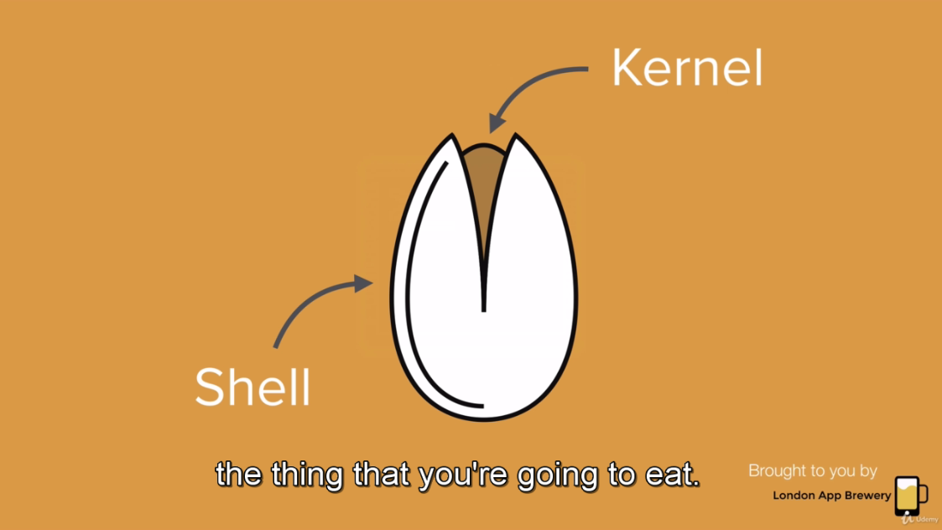

Kernel is actual program. Shell computing first as the user interface.

Bash shell

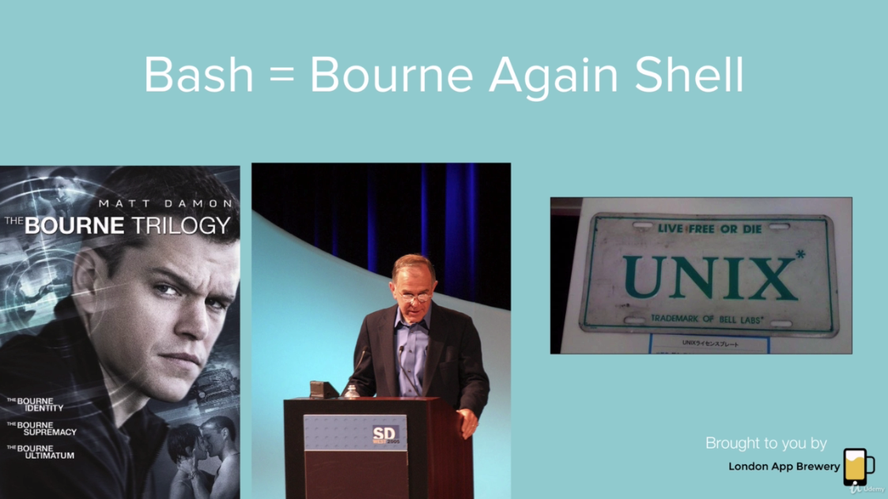



It’s very easier and faster to do a lot of really common things. Using command line we can show unnecessary libraries/files that are hidden by default in **macos** as well as in **apple**.

**Command Line Directories**

cd.. //change directory

cd users.. //set user directory

mkdir .Secrets //Unhide macos secrets

Let’s create folder using hyper directories

**mkdir Music //mkdir means making directory**